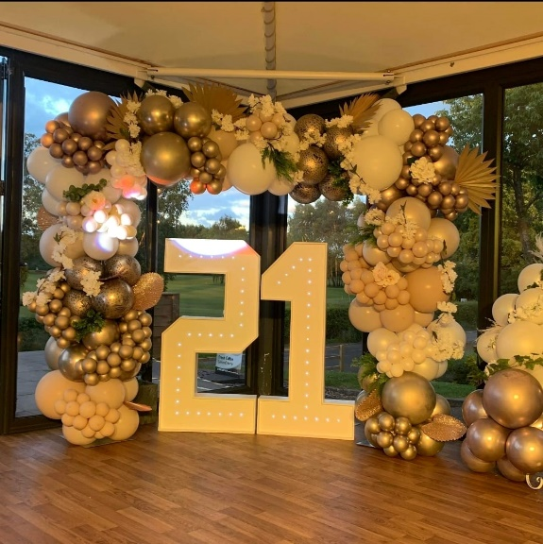
Tied with a bow balloons
And events

BALLOON AFTERCARE

Please keep your balloon displays
Away from heat/direct sunlight. Balloons expand and contract in hot and cold conditions. These conditions might cause your balloon display to pop or deflate unfortunately this is out of our control and we do not take liability for this if they have been kept in conditions as above.

Your balloons are delicate, please handle them with care.

Be sure to keep balloons away from any sharp objects as this can cause them to pop.

Balloons can go through a process called oxidation, this is a natural process which cannot be controlled this can cause balloons to look matte and clear balloons looking cloudy, sunlight and heat can speed this reaction up.

While every effort is made to ensure the longevity of your balloon life please be aware some natural reactions are out of our control that being said, it is also the customers responsibility to make sure they are also doing their part to make sure you get the best out of your service with us and children and animals are supervised at all times as we are not liable once the balloon displays leave our hands.

